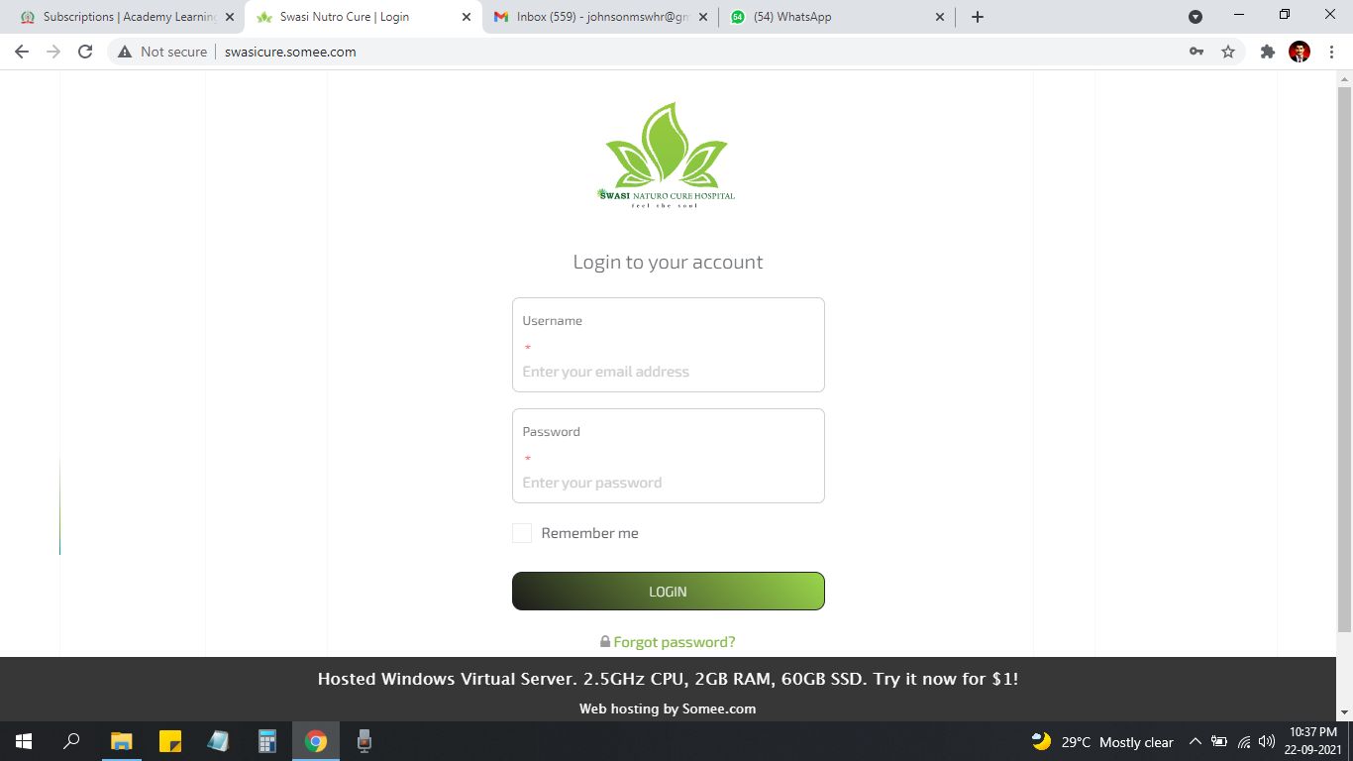

* Password View Option venum - Fixed.

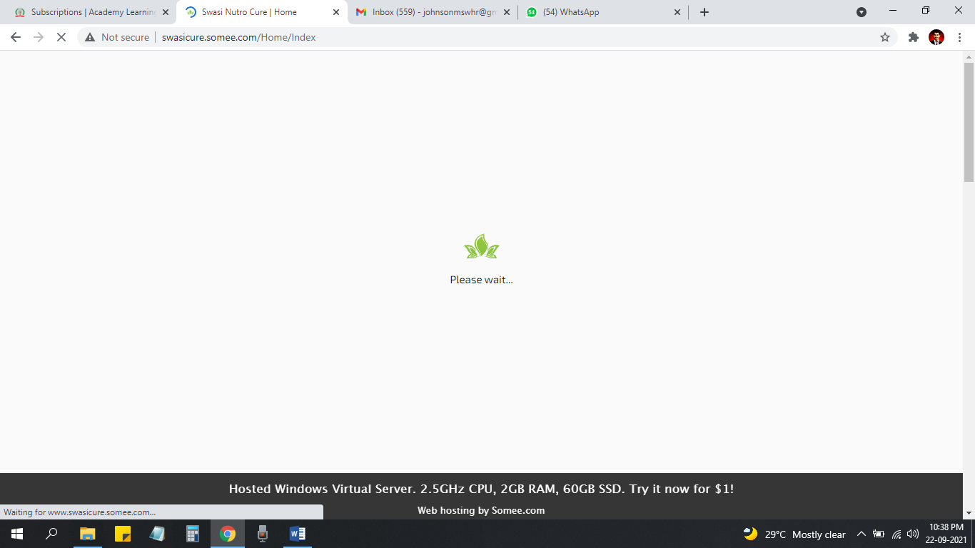

Logo size konjam perusa vaikanum… Animation ethum ready pana kudutha vaika mudiuma… or no issues -

Logo size look like professional and user like convenient

Animation ethum ready pana kudutha vaika mudiuma - possible but based on your animation.

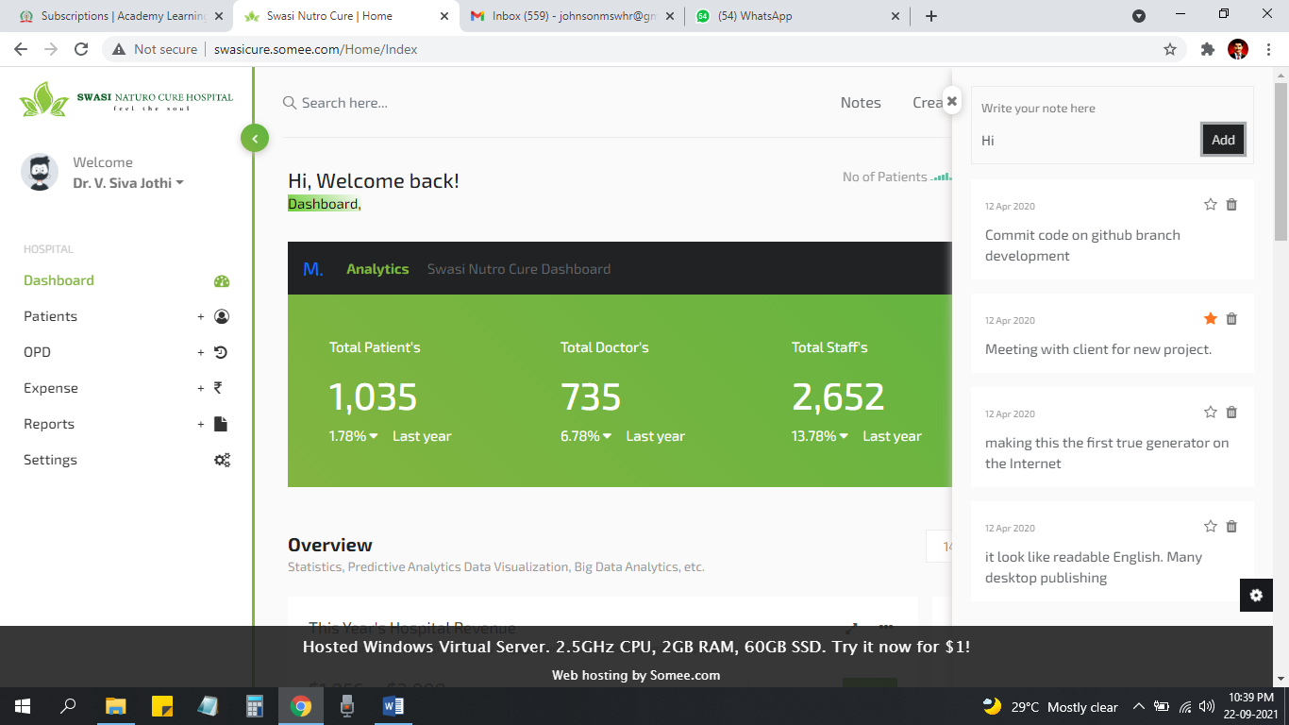

Intha Place la Just add delete ku mattum option venum ,

Which add delete pls mention

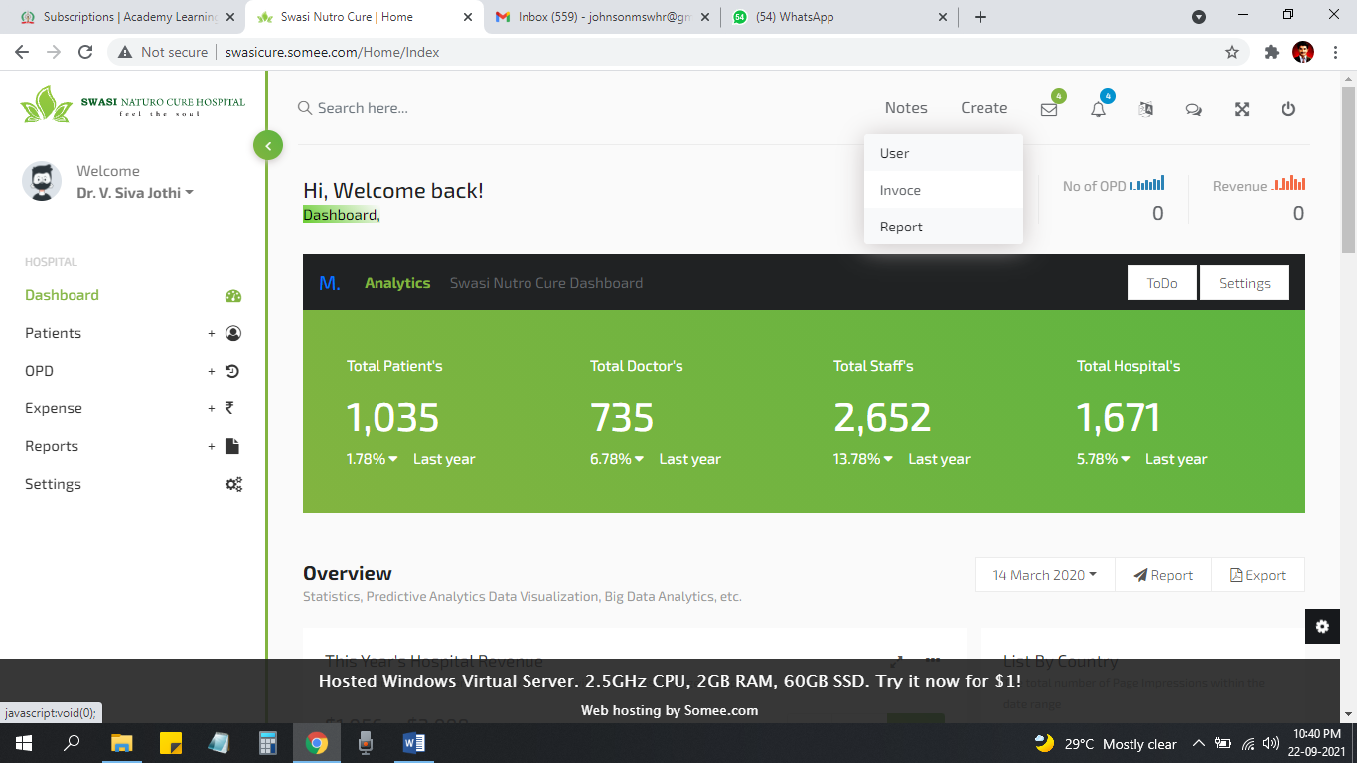

Ithu short cut functionality than… itha konjam add panita better…

1. Create Patient
2. Create OPD
3. Create Purchase (Medicine)
4. Create Expense

Fixed

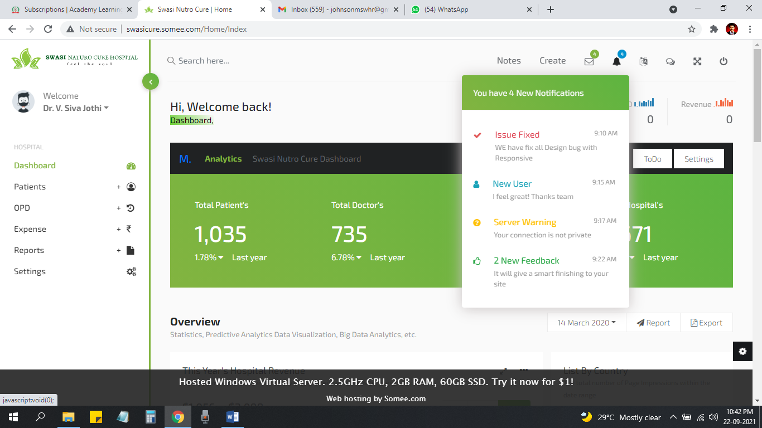

Intha place la thevai ilatha buttons ah remove panidalam Fixed

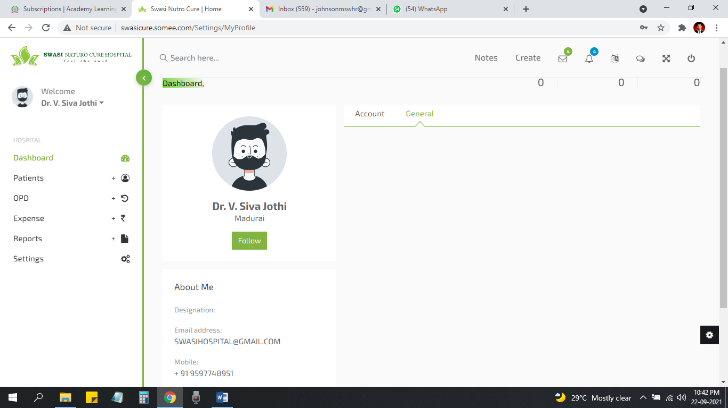

1. General la ethume ila… so itha remove panidalam la fixed
2. Photo add pana option vaikalama or Venama vakalam
3. Designation view aagala… but nan kuduthuruken

Fixed

C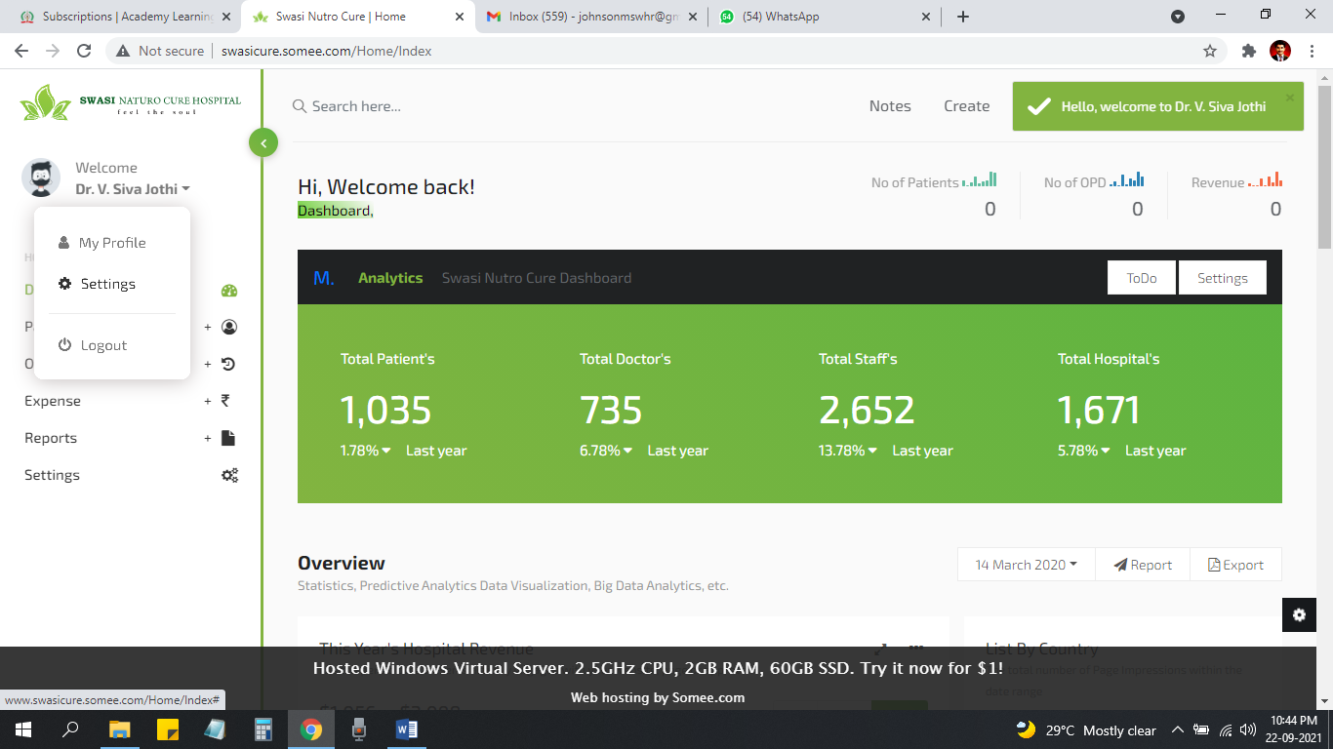

Settings page la functionality liana atha remove panidalam Fixed

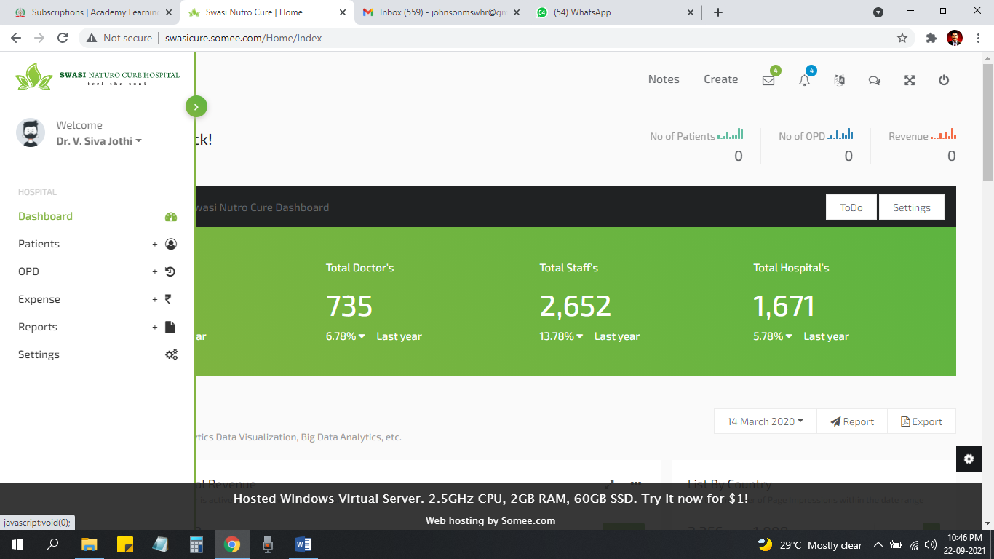

* Intha place la mattum check paniko… menus la

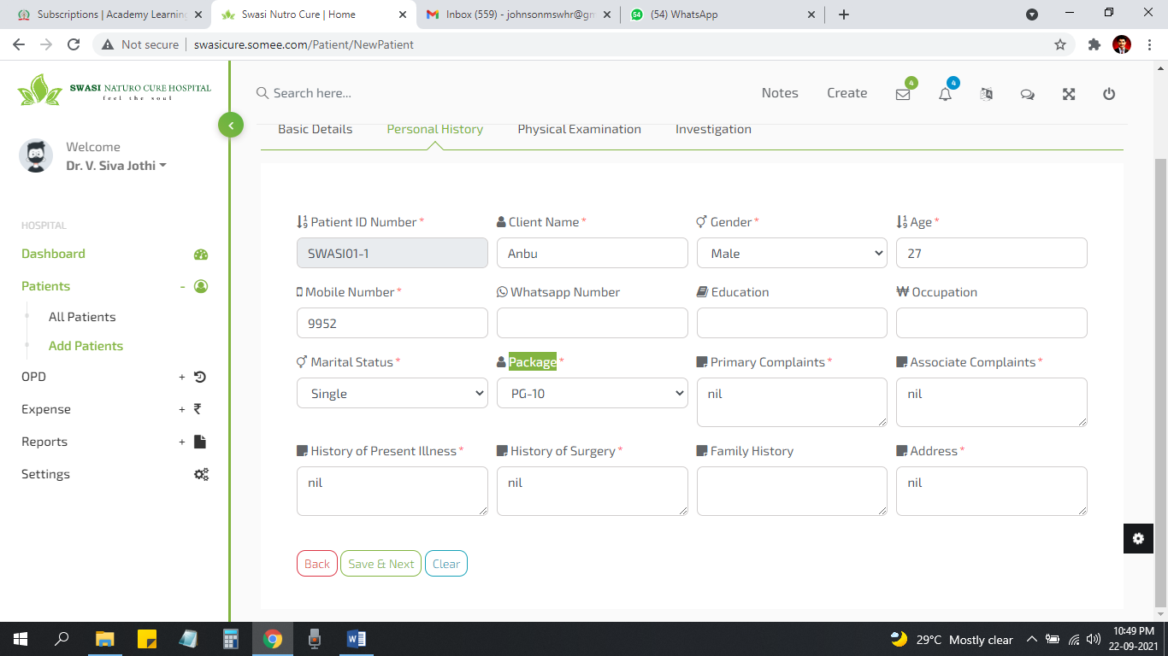

* Package Not mandatory Fixed
* Mobile number validate pananum Fixed
* Need **Save and Exit** Button (Itha Receptionist fill panita balance ullatha doctor than fill pananum) fixed
* Patient add panitu submit kudutha error kattuthu ,fixed

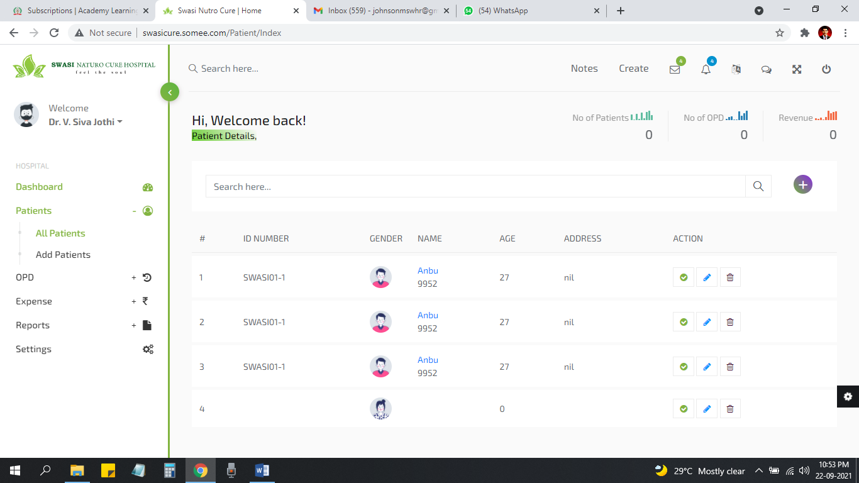

One time than fill panen… error katuchu then 3 entry vilunthuruku Fixed

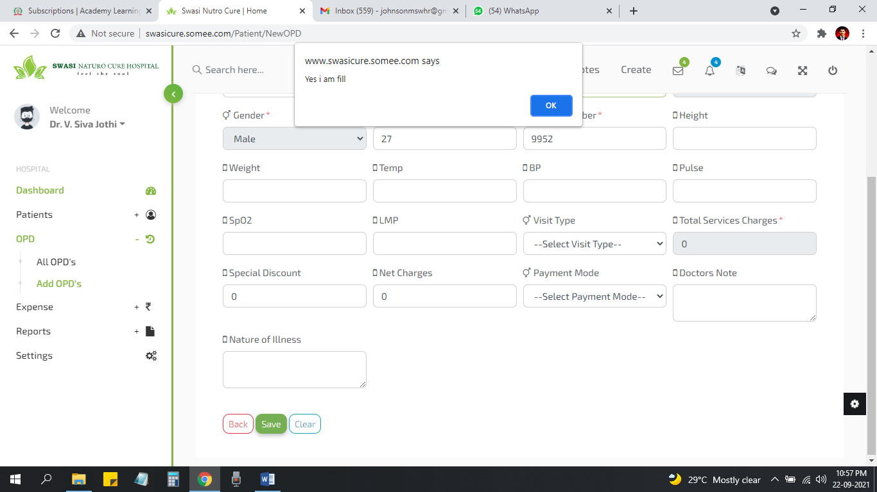

Doctors Note & NATURE of illness mandatory Fixed

Intha popup thevai ila Fixed

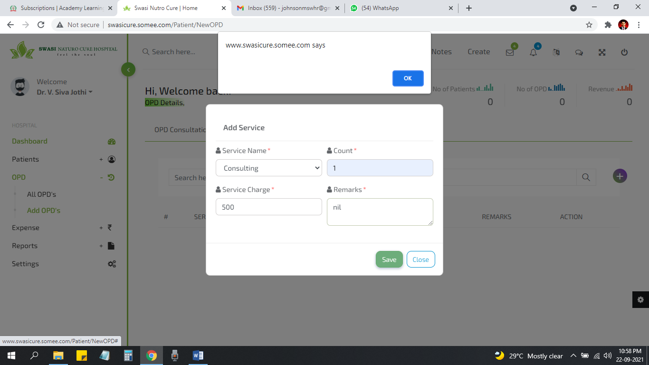

No need this popup too Fixed

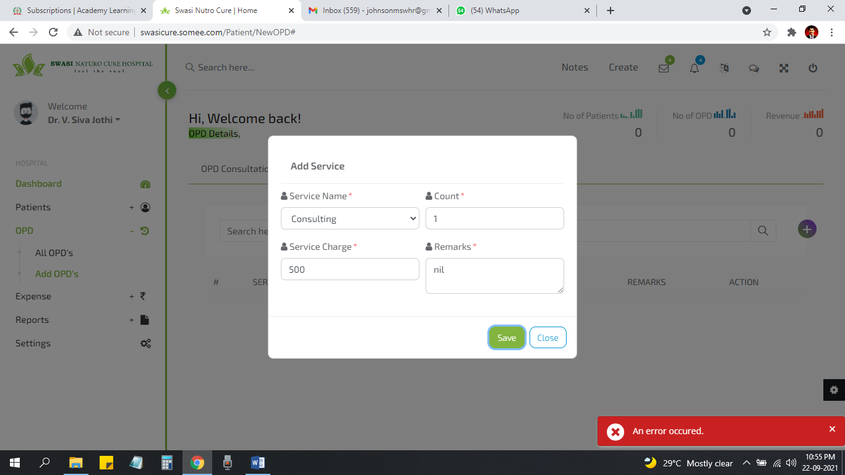

Not able to add OPD services… OPD service Add aagala Fixed

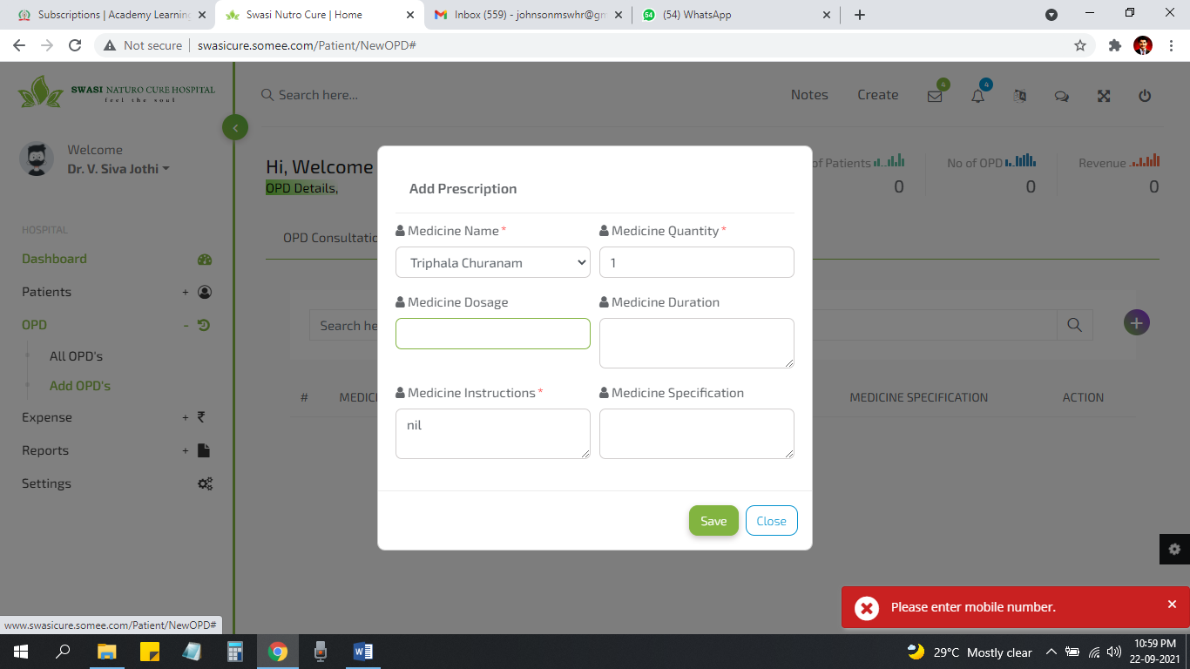

Check this Error message Fixed

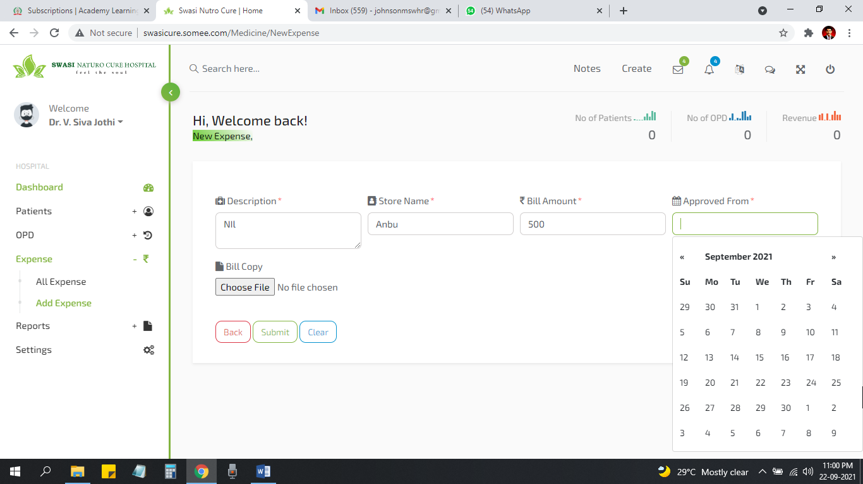

Approved from Name than add pananum so athu **text box than varum**

**Date venum**

**Important Note**

* **Reports Page Error varuthu**
* **Purchase medicine (Add pananaum) (All Mandatory)**
  1. S.No
  2. Date
  3. Medicine (Dropdown)
  4. Current stock (Non editable)(Automatic ah view aaganum
  5. Quantity purchase
  6. Bill amount
  7. Mode of payment
  8. Paid on (Calendar)
  9. Approved from (text box) NEED CLARIFICATION

**Appointments Add pana option venum… But No urgent…**

* Date
* Name
* Phone No
* District
* Reason for Appointment
* Doctor Name(Expecting Doctor)